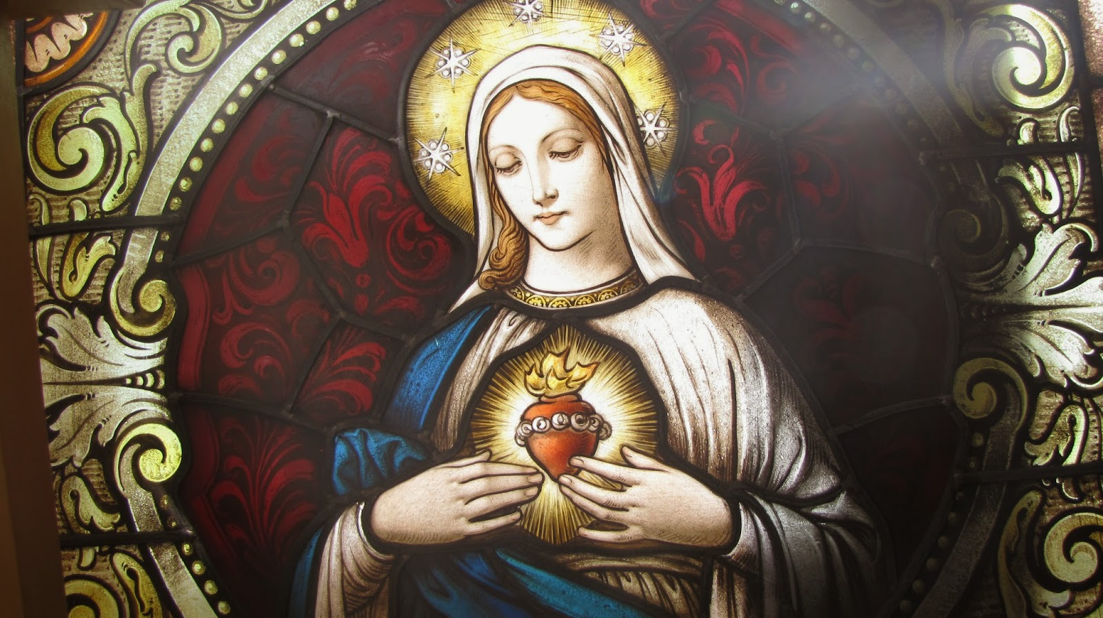
Consecration to Mary

On Friday, May 1, Archbishop Gomez will lead the country in a prayer which consecrates the United States to Mary, Mother of the Church.
Canada, too, has chosen this day to offer prayers and to consecrate their country to Mary, Mother of the Church.

“This will give the Church the occasion to pray for Our Lady’s continued protection of the vulnerable, healing of the unwell, and wisdom for those who work to cure this terrible virus,” said Archbishop Gomez in a letter to the U.S. bishops. Each year, the Church seeks the special intercession of the Mother of God during the month of May. “This year, we seek the assistance of Our Lady all the more earnestly as we face together the effects of the global pandemic,” he continued.

For more information, please visit, http://usccb.org/news/2020/20-65.cfm
For additional information and a link to the Facebook feed: https://lacatholics.org/consecration/

Archbishop Gomez will lead a brief liturgy with the prayer of re-consecration on Friday, May 1 at 3:00 pm EDT and has invited the bishops to join in from their respective dioceses and asked them to extend the invitation to the faithful in their dioceses for their participation. A liturgy guide will be available to assist the faithful who may join in by tuning into the USCCB’s social media platforms: Facebook, Twitter, and Instagram.

Note: This prayer entrusts the country to Mary, Mother of the Church, it does not change the fact that our official national patroness is Mary, under her title of the Immaculate Conception. Our national patronal solemnity remains December 8.

Pope Francis recommends the practice — here are some great resources to help you get started

Several popes in the last century have not only recommended the practice of consecration to the Immaculate Heart of Mary, but have practiced it themselves. Pius XII and St. John Paul II even consecrated the peoples of the earth to her heart.
Most recently, Pope Francis has recommended this practice and followed the example of his predecessors by consecrating the entire world to the Immaculate Heart of Mary. He related to the crowds gathered at St. Peter’s for the consecration how Mary “takes us with the hand of a mother to the embrace of the Father, to the Father of mercy.”
Consecration to the Blessed Mother reminds us of the close connection Mary has with Jesus, and how she treasured everything she saw, “in her heart” (cf. Luke 2:19,51). Pope Benedict XVI reflected on this profound mystery on the feast of the Immaculate Heart of Mary, where he said, “The heart that resembles that of Christ more than any other is without a doubt the Heart of Mary, his Immaculate Mother, and for this very reason the liturgy holds them up together for our veneration.” Marian consecration is an exterior way that speaks of our interior desire to follow God’s will and unite our heart with His.

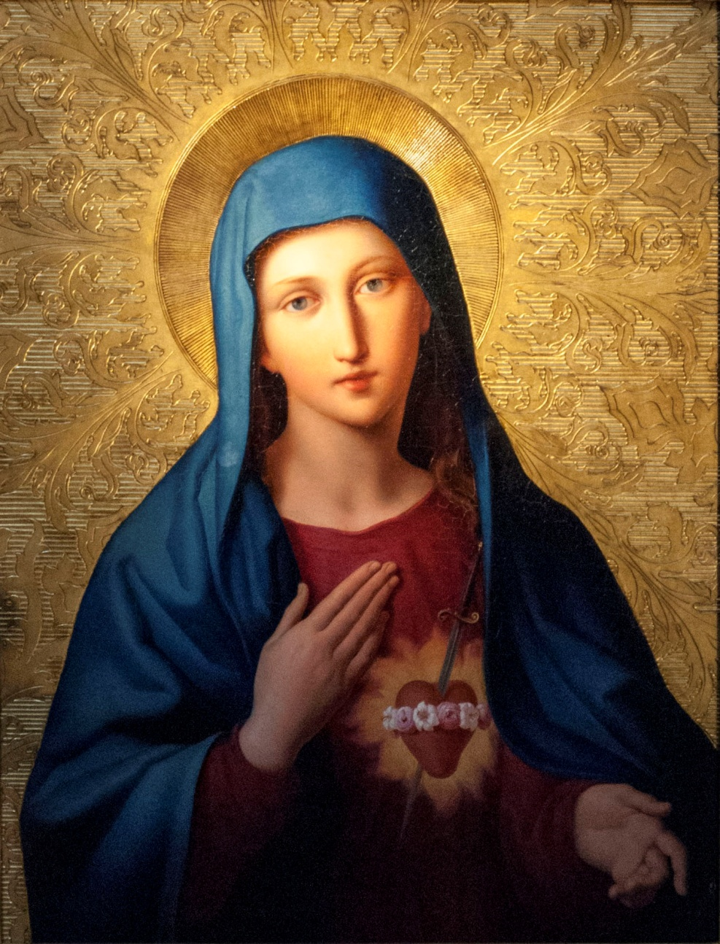

A Solemn Act of Consecration to
the Immaculate Heart of Mary
and Mother of the Church
Pope Pius XI

Most Holy Virgin Mary, tender Mother of men, to fulfill the desires of the Sacred Heart of Jesus and the request of the Vicar of Your Son on earth, we consecrate ourselves and our families to your Sorrowful and Immaculate Heart, O Queen of the Most Holy Rosary, and we recommend to You, all the people of our country and all the world.
Please accept our consecration, dearest Mother, and use us as You wish to accomplish Your designs in the world.

O Sorrowful and Immaculate Heart of Mary, Queen of the Most Holy Rosary, and Queen of the World, rule over us, together with the Sacred Heart of Jesus Christ, Our King. Save us from the spreading flood of modern paganism; kindle in our hearts and homes the love of purity, the practice of a virtuous life, an ardent zeal for souls, and a desire to pray the Rosary more faithfully.

We come with confidence to You, O Throne of Grace and Mother of Fair Love. Inflame us with the same Divine Fire which has inflamed Your own Sorrowful and Immaculate Heart. Make our hearts and homes Your shrine, and through us, make the Heart of Jesus, together with your rule, triumph in every heart and home. Amen.

Prayer of Consecration of the Family

Sacred Heart of Jesus and Immaculate Heart of Mary, I come to you to consecrate myself and my entire family to your two hearts. I desire to renew the vows of my baptism
and place each member of my family through an act of faith, hope and love into loving union with the Holy Family.

At Fatima, dear Mother of God, you appeared with St. Joseph and the Child Jesus blessing the world. Bestow blessings upon our family so that we may live in Christ. I desire that each member of my family adore always the Most Blessed Trinity and love our God in the Most Blessed Sacrament.

Keep each member of my family in the grace of your Son,
Jesus Christ. Never permit any of my family to stray
from You and the true faith. For those who have strayed,
I ask You to bind up the wounds, lift up the fallen,
and by the power of the Holy Spirit, lead them back to
their true home, the Church. Amen.

Prayer of Consecration of our Nation
to Mary the Mother of the Church

O Mary, Mother of the Church and Mother of mercy,
Queen of Heaven, We consecrate our families, our parish
and our Country to you.

In a special way we ask your Intercession,
Blessed Mother of the Church, to end this pandemic.
We ask you to intercede on behalf of the Church and all the faithful, to ask your Son, Jesus to heal our nation.

We pledge ourselves this day to pray the rosary.
To Jesus, we entrust Him with all our hopes.
He, who gave you to us at the cross as our Mother.

Mother of God, hear our prayer.
Pray for us who have recourse to you. Amen.

Hail Mary

