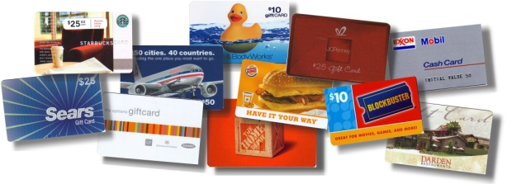
Most Holy Trinity School
Scrip Program
Dear Scrip Supporter:
Would you like to support M.H.T. School without selling anything? Would you like to lower your school tuition payments for your child who is currently attending M.H.T. or who will attend in the future?
Our scrip program is able to do both of those things for you. Scrip is simply a word that means “substitute money” – in other words, scrip is gift certificates from national and local retailers. They’re the same gift certificates that you buy at the store. Many popular retailers participate in our scrip program including JCPenney, Exxon, Kohl’s, Subway, Burger King, Best Buy, Red Lobster and hundreds more.
You’re probably asking yourself how these stores help us raise money. It’s simple -- scrip participating retailers agree to sell gift certificates to our organization at a discount. Member families like yours buy the certificates at full face value, they redeem them for full face value, and our school keeps the difference as revenue. And scrip is exciting, because everybody wins:
- The retailer gets cash up front and repeat business.
- You get a powerful fundraising alternative that involves no selling.
- Our school gets a regular source of revenue.
- You can choose to apply 50% of the rebates earned to your child’s tuition!
- Families can even start earning tuition credits before their children attend M.H.T. School.
- You may designate to have the purchases of family and friends credited to your family’s account.

The beauty of scrip is that you put your regular household shopping dollars to work. You earn money for our school without spending a single additional penny. Just spend your regular shopping dollars with scrip at the stores that participate in the scrip program. Scrip can be used for just about any household purchase including food, clothing, entertainment, gasoline and even dining out.
To purchase scrip, please use the attached order form. Simply fill out an order, include a check for payment, and place it in the collection box at any mass. You may also drop off your order in the rectory mailbox or at the school office during regular school hours. Orders will be processed on Monday mornings and are generally ready for pick up in the school office by Thursday morning. Orders can also be placed on-line at www.shopwithscrip.com (please use school code 73F4AA69227). In addition, we keep a limited number of cards in stock to purchase on a cash and carry basis.
An enrollment form can be found on the school website. If you have questions, please call the school office at 593-2616. Additional information, such as the scrip policy and registering Kroger cards, can be found at our parish website www.mhtparish.com/school . Thank you for your support!!!!

Most Holy Trinity School – Connecting Faith to Life

